Jungle

Jungle is an old Indian game, also known as Jungle Chess (however, due to many differences it is not included in chess category). It is played on 7 x 9 board which contains water fields, player lairs and traps.

The Jungle gameboard represents a jungle terrain with dens, traps "set" around dens, and rivers. Each player controls eight game pieces representing different animals of various rank. Stronger-ranked animals can capture ("eat") animals of weaker or equal rank. The player who is first to maneuver any one of their pieces into the opponent's den wins the game. An alternative way to win is to capture all the opponent's pieces.

The Jungle Board

There are several special squares and areas of the Jungle board:

* Each player has one **den** (獸穴) square located in the center of their first row of the board.
* Three **traps** (陷阱) border each den, to each side and in front.
* Two **water areas or rivers** (小河) are in the center of the board, each comprising 6 squares in a 2×3 rectangle. There are single columns of ordinary land squares on the edges of the board, and down the middle between the rivers.

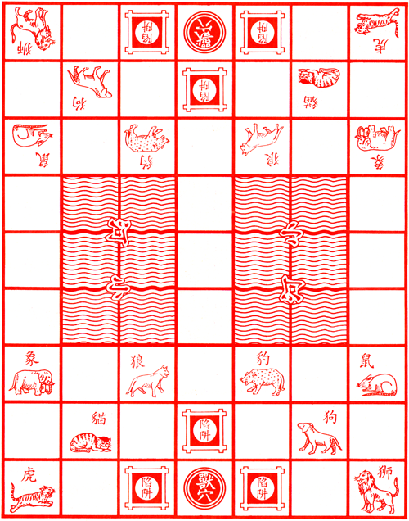

Pieces

Each player has eight game pieces representing different animals, each with a different rank, and in their own color (blue versus red). The animal ranking, from strongest to weakest, is visible in the table on the right.

Pieces start on squares with pictures corresponding to their animal, which are invariably shown on the Jungle board.

1. **Elephant** (象): Elephant is the strongest animal and can capture all other animals except a mouse
2. **Lion** (獅): Lion can make (as an addition to its normal moves) jumps over a water. It means that if it stands next to a blue square and the corresponding target square behind the water is empty or occupied by an animal it can eat, the lion is allowed to perform a jump move. There is one exception - it is not possible to jump if a mouse (player's or opponent's) is blocking the jump path.
3. **Tiger** (虎): Tiger has the same jumping abilities as lion. Several typical situations are displayed in the next picture:

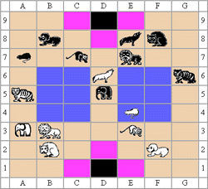

In this position, white lion can make a B3-B7 jump, white tiger cannot jump from A5 to D5 because the target square is occupied by a stronger enemy, black lion cannot jump to E3 (there is a mouse on E4, blocking the way) and black tiger may jump to D6, eating opponent's wolf.

1. **Leopard** (豹): Leopard has no extra moves or abilities.
2. **Wolf** (狼): Wolf has no extra moves or abilities.
3. **Dog** (狗): Dog has no extra moves or abilities.
4. **Cat** (貓): Cat has no extra moves or abilities.
5. **Mouse** (鼠): Mouse is the most interesting piece in this game. Although it is the smallest and weakest one, it can kill an elephant (there was a myth that a mouse can get in an elephant's ear and eat his brain). Mouse is also the only animal which can go to a water (blue squares) and block lion's or tiger's jumps. However, a mouse in a water cannot capture enemy elephant by jumping out of the water, it must make another move and get out of the water first. A mouse jumping from a water can eat only another mouse,

Rules

Win Condition

The game object is to conquer opponent's lair or eat all enemy animals, so the game is finished if one of the following conditions is fulfilled:

* Any player's animal steps in opponent's den. This player wins the game.
* A player cannot make a valid move. This player loses the game. (If a player doesn’t have any animal left, he cannot make a valid move)

Movement

The basic move options of all pieces are one space horizontally or vertically to a square which is empty or occupied by an enemy animal (if it is possible to capture it, see detailed rules in the next section). Only the rat can move in the water and no animal can go into its own lair.

Capturing

Animals capture opponent pieces by "killing/eating" them (the attacking piece replaces the captured piece on its square; the captured piece is removed from the game). A piece can capture any enemy piece that has the same or lower rank, with the following exceptions:

* The rat can "kill" (capture) an elephant, but only from a land square, not from a water square.
* A rat in the water is invulnerable to capture by any piece on land. (Therefore, a rat in the water can only be killed by another rat in the water.)
* A piece that enters one of the opponent's trap squares is reduced in rank to 0. Thus, the trapped piece may be captured by the defending side with any piece, regardless of rank. A trapped piece has its normal rank restored when it exits an opponent's trap square.